Test Case: tc002_SPX_Dev5_Crear_Requisicion_Spot_Con_FAD_Tipo_Cobro_CC
Step 1 - Enter username and password and click to button Enter : Credentials Entered
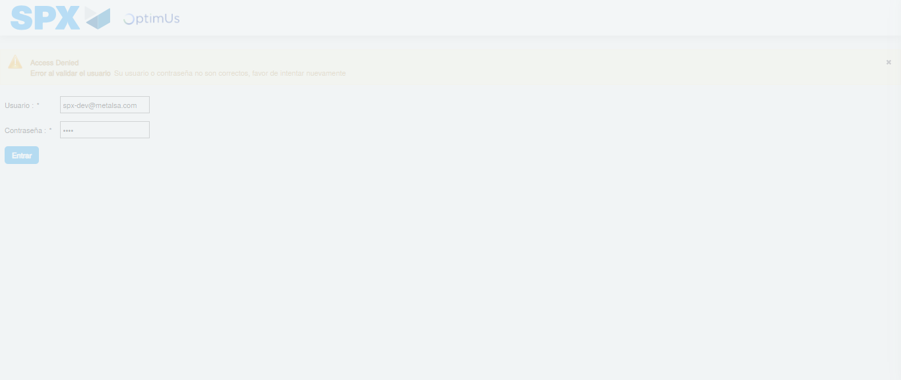Image file-name: QC_Testing-tc002_SPX_Dev5_Crear_Requisicion_Spot_Con_FAD_Tipo_Cobro_CC-1782314791710

Step 2 - Select to UEN and Access to Spot Buy Requisitions : UEN Correctly selected and Correct access
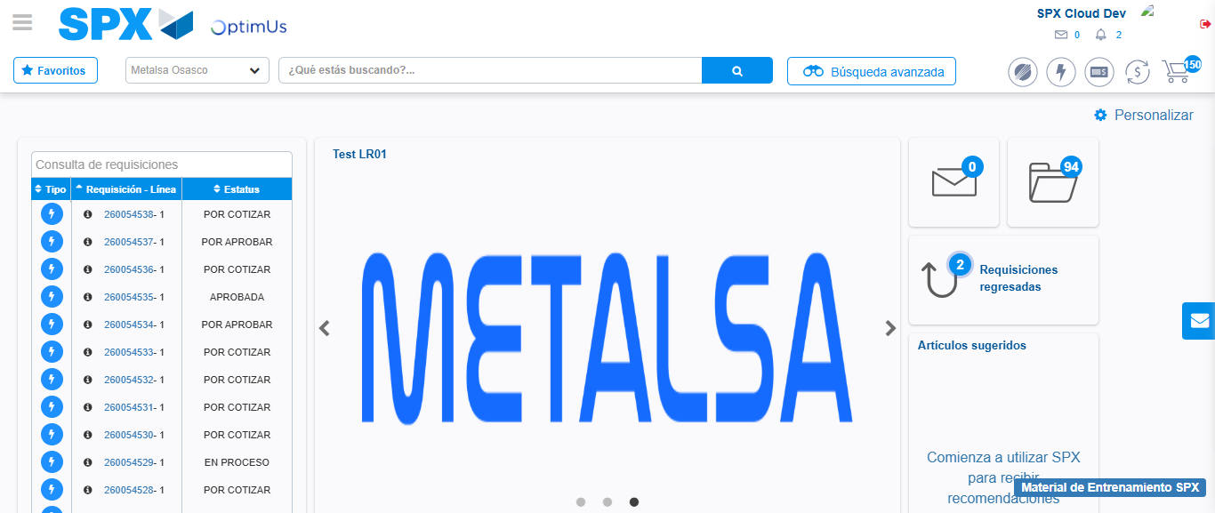Image file-name: QC_Testing-tc002_SPX_Dev5_Crear_Requisicion_Spot_Con_FAD_Tipo_Cobro_CC-1782314869097

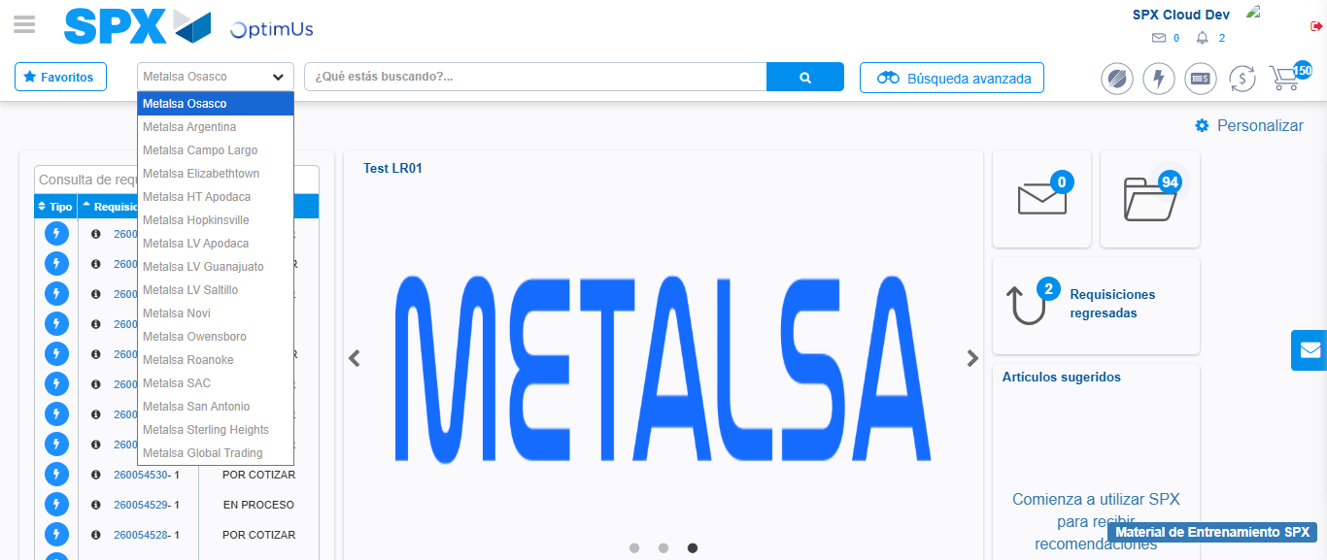Image file-name: QC_Testing-tc002_SPX_Dev5_Crear_Requisicion_Spot_Con_FAD_Tipo_Cobro_CC-1782314871837

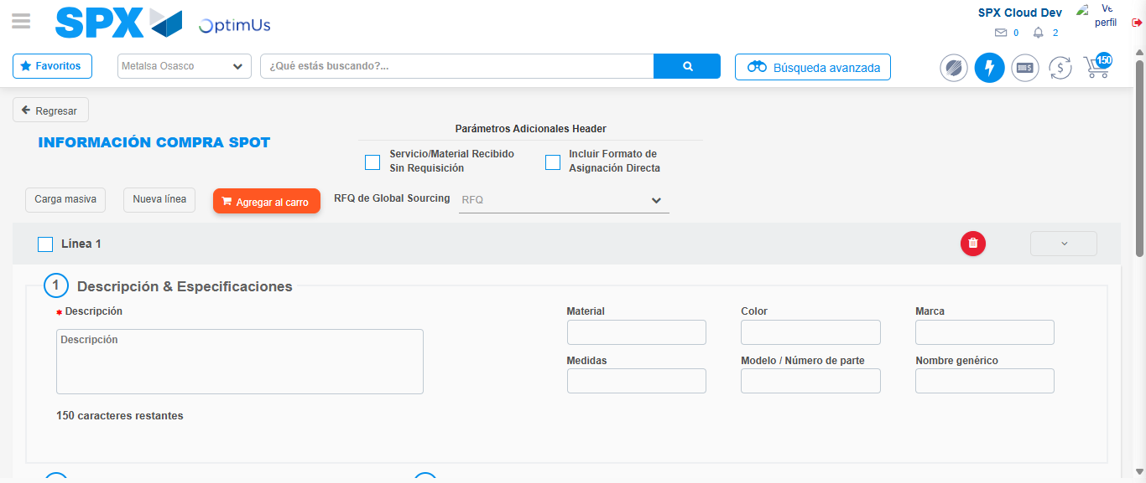Image file-name: QC_Testing-tc002_SPX_Dev5_Crear_Requisicion_Spot_Con_FAD_Tipo_Cobro_CC-1782314882104

Step 3 - Add FAD to Requisition: FAD Successfully Added
Image file-name: QC_Testing-tc002_SPX_Dev5_Crear_Requisicion_Spot_Con_FAD_Tipo_Cobro_CC-1782314882410

Image file-name: QC_Testing-tc002_SPX_Dev5_Crear_Requisicion_Spot_Con_FAD_Tipo_Cobro_CC-1782314882641

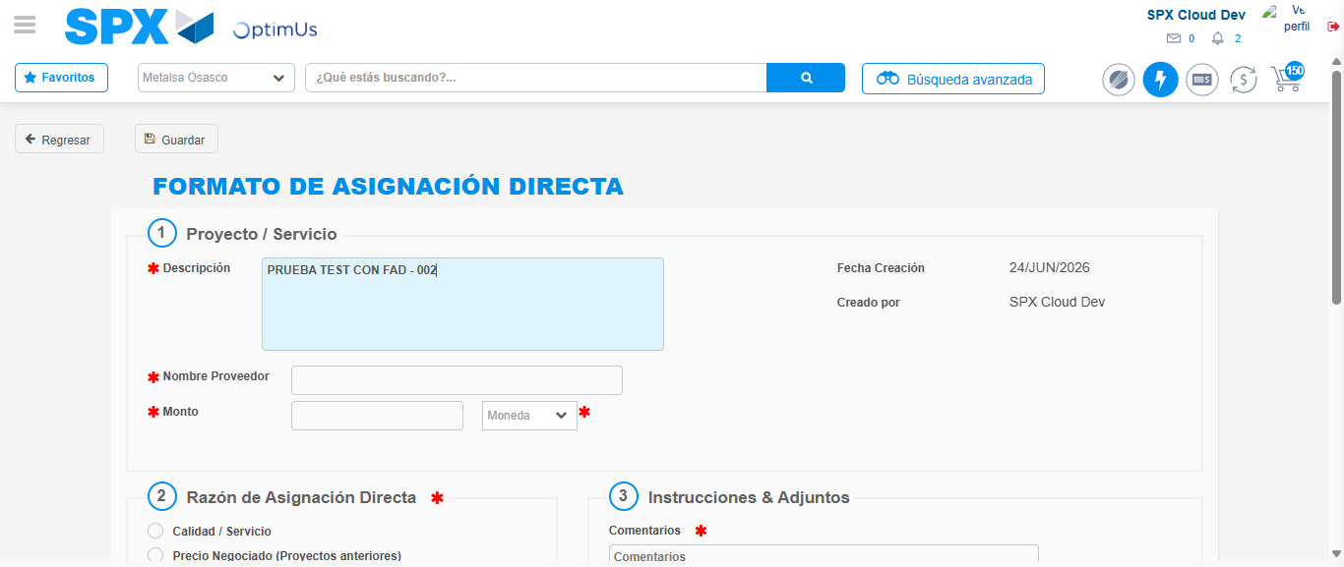Image file-name: QC_Testing-tc002_SPX_Dev5_Crear_Requisicion_Spot_Con_FAD_Tipo_Cobro_CC-1782314885599

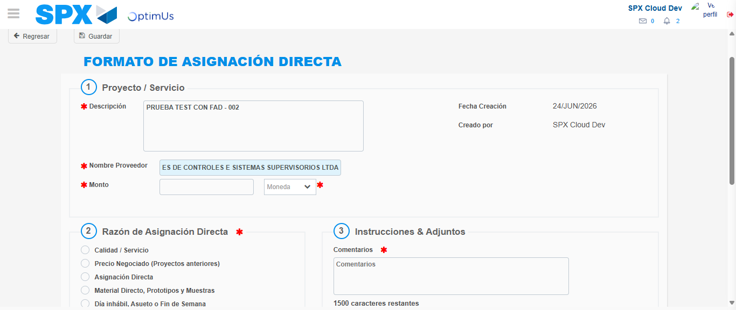Image file-name: QC_Testing-tc002_SPX_Dev5_Crear_Requisicion_Spot_Con_FAD_Tipo_Cobro_CC-1782314896733

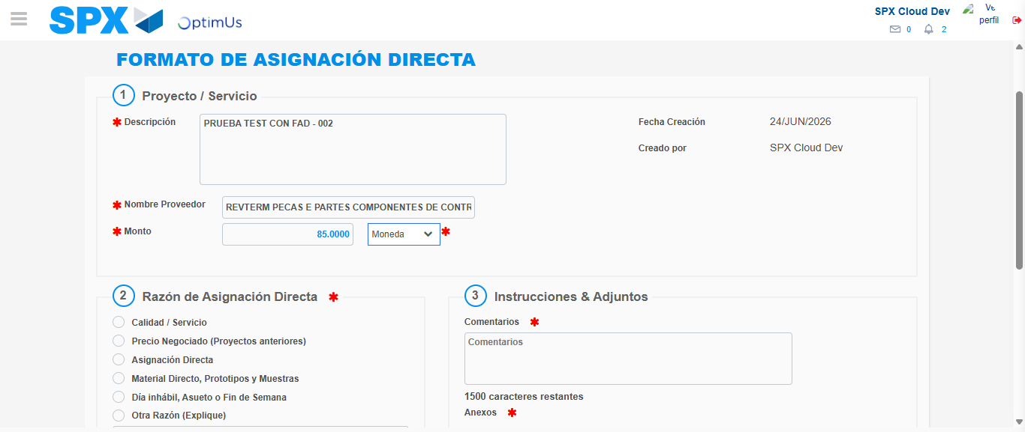Image file-name: QC_Testing-tc002_SPX_Dev5_Crear_Requisicion_Spot_Con_FAD_Tipo_Cobro_CC-1782314897255

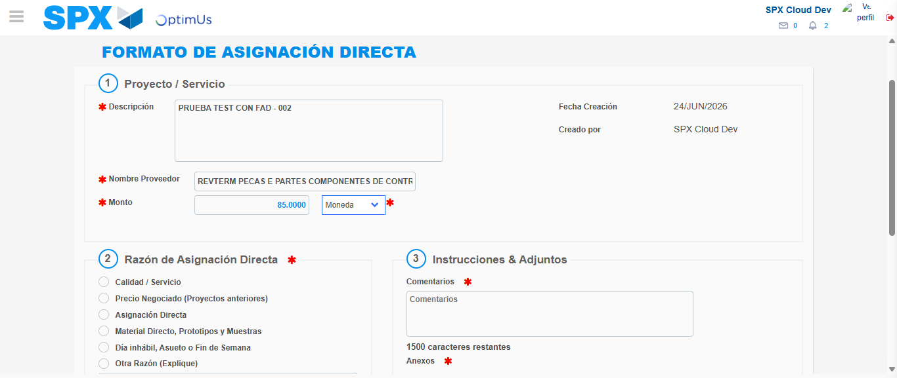Image file-name: QC_Testing-tc002_SPX_Dev5_Crear_Requisicion_Spot_Con_FAD_Tipo_Cobro_CC-1782314897530

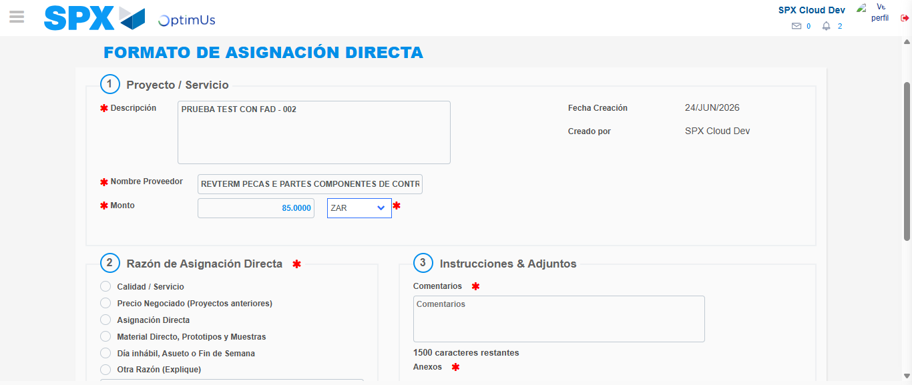Image file-name: QC_Testing-tc002_SPX_Dev5_Crear_Requisicion_Spot_Con_FAD_Tipo_Cobro_CC-1782314898126

Image file-name: QC_Testing-tc002_SPX_Dev5_Crear_Requisicion_Spot_Con_FAD_Tipo_Cobro_CC-1782314898368

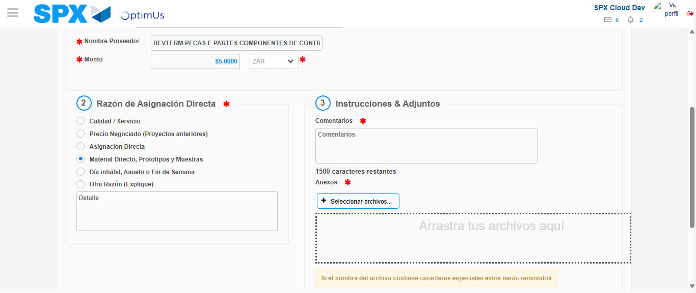Image file-name: QC_Testing-tc002_SPX_Dev5_Crear_Requisicion_Spot_Con_FAD_Tipo_Cobro_CC-1782314899302

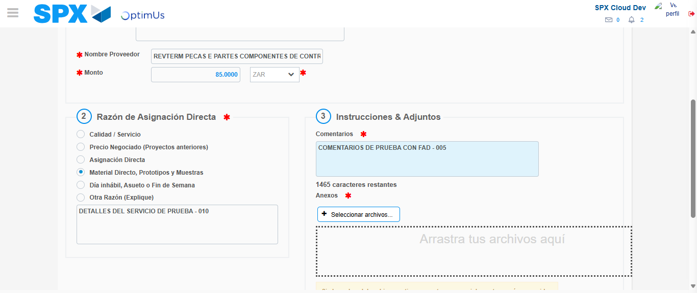Image file-name: QC_Testing-tc002_SPX_Dev5_Crear_Requisicion_Spot_Con_FAD_Tipo_Cobro_CC-1782314910408

Image file-name: QC_Testing-tc002_SPX_Dev5_Crear_Requisicion_Spot_Con_FAD_Tipo_Cobro_CC-1782314911352

Step 4 - Data Capture Spot Buy Requisition: Data captured correctly
Image file-name: QC_Testing-tc002_SPX_Dev5_Crear_Requisicion_Spot_Con_FAD_Tipo_Cobro_CC-1782314882410

Image file-name: QC_Testing-tc002_SPX_Dev5_Crear_Requisicion_Spot_Con_FAD_Tipo_Cobro_CC-1782314882641

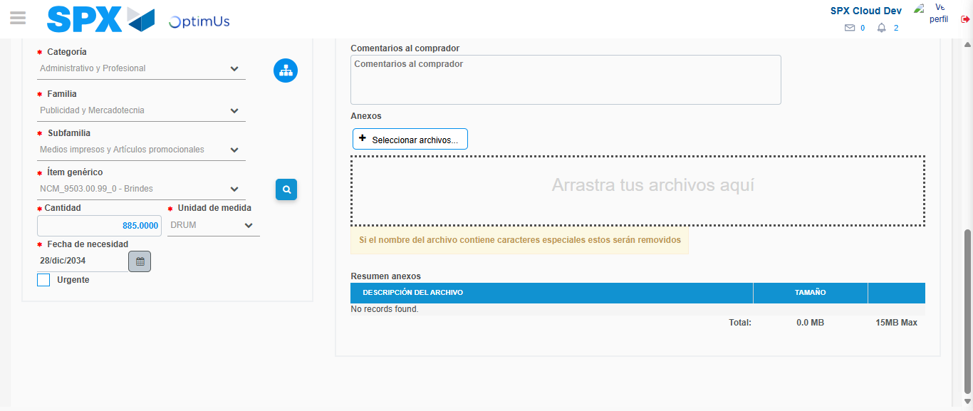Image file-name: QC_Testing-tc002_SPX_Dev5_Crear_Requisicion_Spot_Con_FAD_Tipo_Cobro_CC-1782314926181

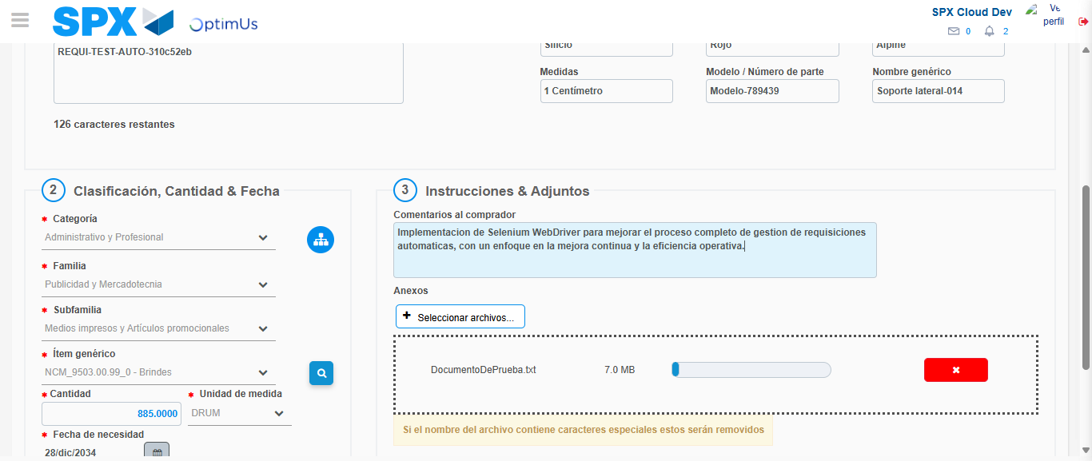Image file-name: QC_Testing-tc002_SPX_Dev5_Crear_Requisicion_Spot_Con_FAD_Tipo_Cobro_CC-1782314927108

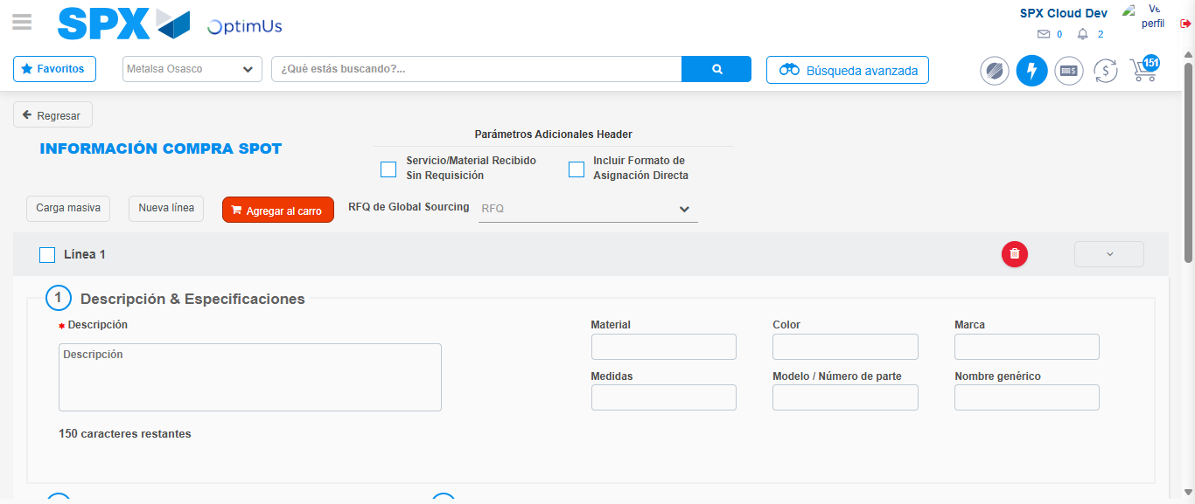Image file-name: QC_Testing-tc002_SPX_Dev5_Crear_Requisicion_Spot_Con_FAD_Tipo_Cobro_CC-1782314935403

Step 8 - Return to Main Page SPX : Return to Main Page SPX
Image file-name: QC_Testing-tc002_SPX_Dev5_Crear_Requisicion_Spot_Con_FAD_Tipo_Cobro_CC-1782314869097

Image file-name: QC_Testing-tc002_SPX_Dev5_Crear_Requisicion_Spot_Con_FAD_Tipo_Cobro_CC-1782314871837

Image file-name: QC_Testing-tc002_SPX_Dev5_Crear_Requisicion_Spot_Con_FAD_Tipo_Cobro_CC-1782314882104

Image file-name: QC_Testing-tc002_SPX_Dev5_Crear_Requisicion_Spot_Con_FAD_Tipo_Cobro_CC-1782314937740

Image file-name: QC_Testing-tc002_SPX_Dev5_Crear_Requisicion_Spot_Con_FAD_Tipo_Cobro_CC-1782314937972

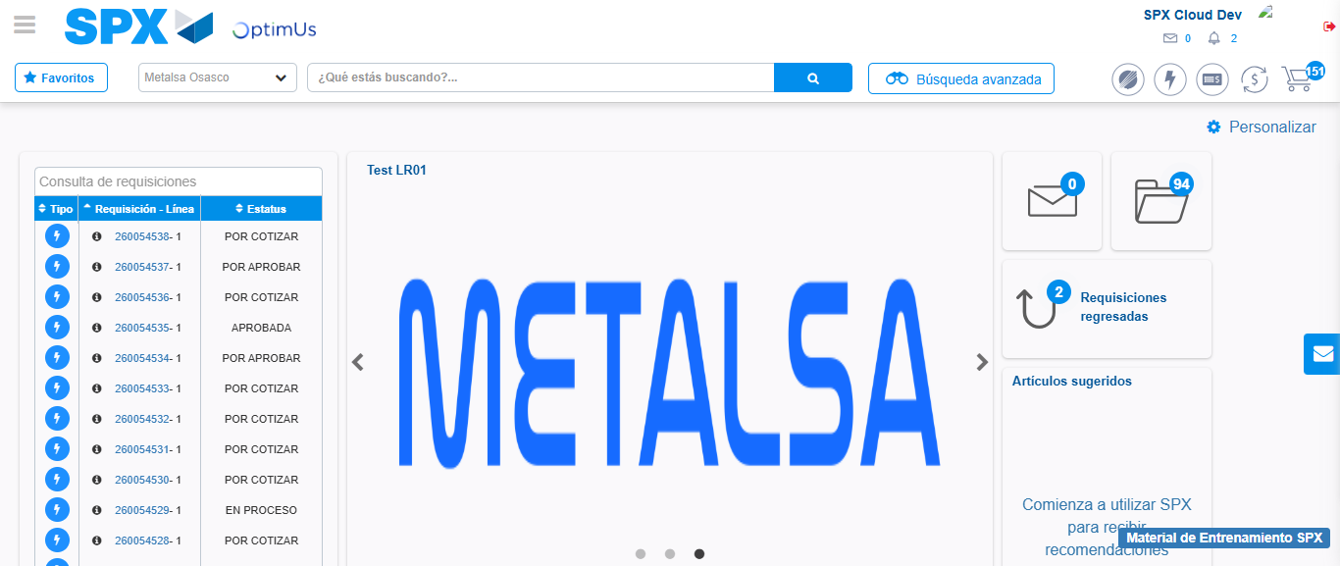Image file-name: QC_Testing-tc002_SPX_Dev5_Crear_Requisicion_Spot_Con_FAD_Tipo_Cobro_CC-1782314959238

Step 9 - Log Out : Log Out SPX
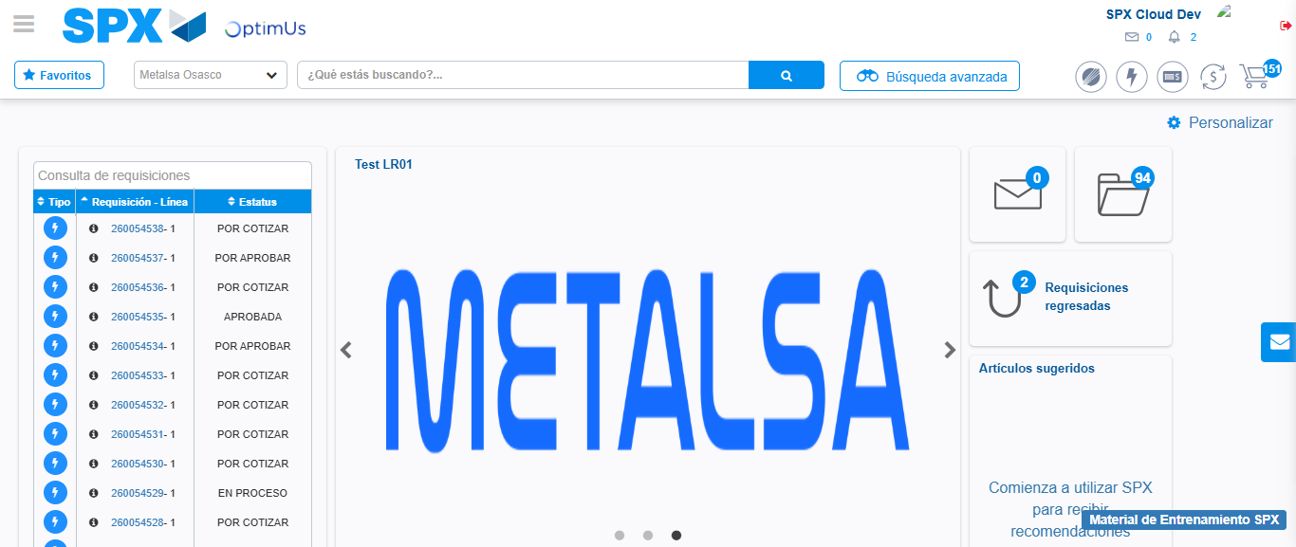Image file-name: QC_Testing-tc002_SPX_Dev5_Crear_Requisicion_Spot_Con_FAD_Tipo_Cobro_CC-1782314959600

